[azarudeen_cloud_1998@centos-server-04 ~]$ docker ps

CONTAINER ID IMAGE COMMAND CREATED STATUS PORTS NAMES

[azarudeen_cloud_1998@centos-server-04 ~]$ docker images

REPOSITORY TAG IMAGE ID CREATED SIZE

[azarudeen_cloud_1998@centos-server-04 ~]$ docker pull nginx

Using default tag: latest

latest: Pulling from library/nginx

3f9582a2cbe7: Pull complete

9a8c6f286718: Pull complete

e81b85700bc2: Pull complete

73ae4d451120: Pull complete

6058e3569a68: Pull complete

3a1b8f201356: Pull complete

Digest: sha256:1ed4dff2b99011798f2c228667d7cb4f4e2bd76b2adc78fd881d39f923e78c9d

Status: Downloaded newer image for nginx:latest

docker.io/library/nginx:latest

azarudeen_cloud_1998@centos-server-04 ~]$ docker images

REPOSITORY TAG IMAGE ID CREATED SIZE

nginx latest 904b8cb13b93 3 weeks ago 142MB

[azarudeen_cloud_1998@centos-server-04 ~]$ docker ps -a

CONTAINER ID IMAGE COMMAND CREATED STATUS PORTS NAMES

[azarudeen_cloud_1998@centos-server-04 ~]$ docker run --name My-nginx -dti -p 8080:80 904b8cb13b93

4f45e232270c4b3b784deb17621373c4018465722372e11055f7e6a88bb61c12

[azarudeen_cloud_1998@centos-server-04 ~]$ docker ps -a

CONTAINER ID IMAGE COMMAND CREATED STATUS PORTS NAMES

4f45e232270c 904b8cb13b93 "/docker-entrypoint.…" 4 seconds ago Up 4 seconds 0.0.0.0:8080->80/tcp, :::8080->80/tcp My-nginx

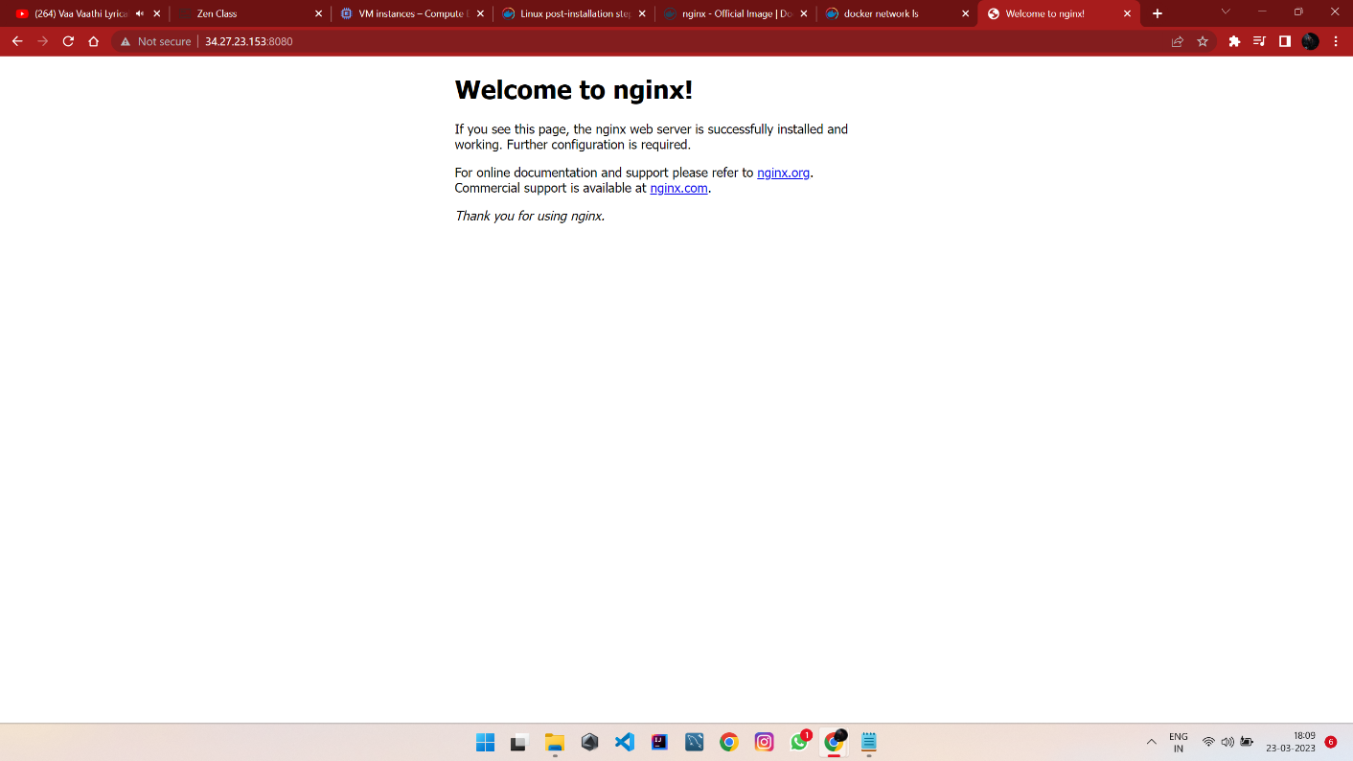

[azarudeen_cloud_1998@centos-server-04 ~]$ docker stop My-nginx

My-nginx

[azarudeen_cloud_1998@centos-server-04 ~]$ docker ps

CONTAINER ID IMAGE COMMAND CREATED STATUS PORTS NAMES

[azarudeen_cloud_1998@centos-server-04 ~]$ docker ps -a

CONTAINER ID IMAGE COMMAND CREATED STATUS PORTS NAMES

4f45e232270c 904b8cb13b93 "/docker-entrypoint.…" 3 minutes ago Exited (0) 13 seconds ago My-nginx

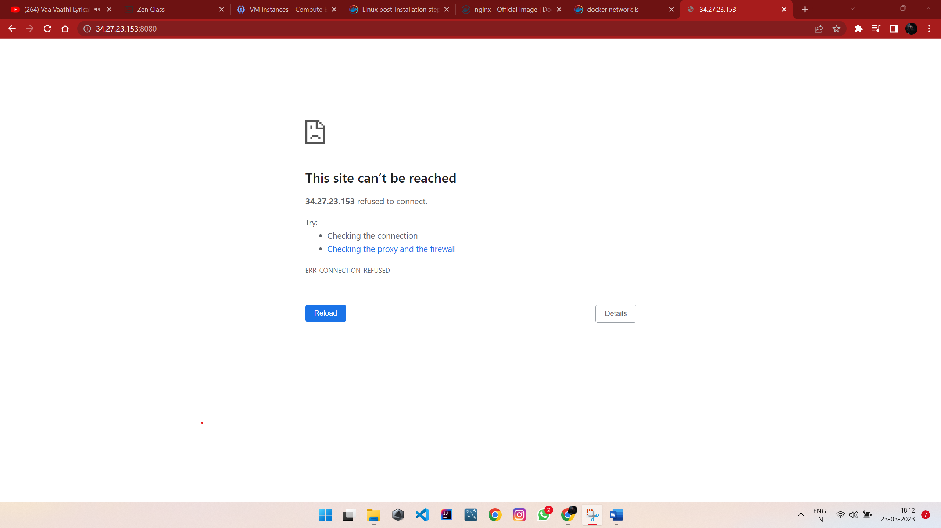

[azarudeen_cloud_1998@centos-server-04 ~]$ docker rm My-nginx

My-nginx

[azarudeen_cloud_1998@centos-server-04 ~]$ docker ps -a

CONTAINER ID IMAGE COMMAND CREATED STATUS PORTS NAMES

[azarudeen_cloud_1998@centos-server-04 ~]$